Robot One Safety Framework – Test & Validation report

Date: 09-12-2025
Version: 0.1
Status: Review
Author: D. Gijsbers

Version control
Version | Date | Description of changes
0.1 | 09-12-2025 | Initial version – added edit & play mode tests

Table of Contents
Version control 2
Introduction 4
Objectives 4
Scope 5
In-Scope 5
Out-of-Scope 5
Test Environment 6
Test Overview and Traceability 6
Test Inventory 6
Traceability tot Hazards / Safety Behaviour 7
Test strategy 8
Detailed test case descriptions 9
TC-OBS-01: Obstacle within threshold triggers Stop (SafetyKernel) 9
TC-MED-01: Trivial safe snapshot, allow and apply 10
TC-MED-02: Obstacle close, Stop applied to robot port 11
TC-FP-01: FieldPatrol does not move when robot is stopped 12
TC-RBT-01: Robot stops on Stop command 13
TC-SIM-01: Simfeeder -> Mediator -> Robot, obstacle causes stop 14
Test execution summary 15
Conclusion and Recommendations 16
Recommended next steps: 16

Introduction
This document describes the tests that were carried out to validate the safety framework for Robot One. The safety framework manages sensor data, safety logic, and robot actions to ensure that hazards such as collisions or uncontrolled movements are prevented.
The tests are implemented in Unity using NUnit edit mode tests and Unity play mode tests. Together they verify:
- Obstacle-based stopping behaviour in the SafetyKernel class.
- Decision-making and how commands are passed through the Mediator.
- Correct execution of Stop commands by the Robot and FieldPatrol behaviour.
- End-to-end integration from SimFeeder to Mediator to SafetyKernel to Robot in the simulated environment.
This report makes the test set traceable and understandable for external reviewers and links the tests to safety behaviour and hazards.

Objectives
The objectives of the test and validation activities are:
- Verify safe responses to obstacles and hazards
  - The SafetyKernel must stop the robot when an obstacle is within a configured threshold.
  - The Mediator must propagate stop decisions to the robot port.
- Validate nominal safe behaviour
  - When all safety-related distances and flags are in a safe state, the framework should allow motion without raising safety reasons.
- Confirm execution of Stop behaviour in motion components
  - A Robot receiving a Stop command should quickly come to a standstill.
  - FieldPatrol must respect the stopped state and not drive the robot.
- Evaluate integration from sensing to actuation
  - SimFeeder must provide sensor data that result in a safe reaction (Stop) in realistic scenes.

Scope

In-Scope
The following components and interactions are covered by the tests in this document:
- SafetyKernel
  - Obstacle-based stopping threshold (obstacle_stop_m).
- Mediator
  - Processing of SensorSnapshot.
  - Interaction with a FakeKernel and FakeRobotPort.
  - Passing Allow and Stop decisions to the robot port.
- Robot (Unity component)
  - Application of RobotCommand with decision Stop.
  - Status flags IsStopped and IsEStopped.
- FieldPatrol behaviour
  - Respecting the stopped state of the robot and not moving the rigidbody.
- SimFeeder
  - Integration with Mediator and Robot in a Unity scene where an obstacle is placed in front of the robot.

Out-of-Scope
- Real hardware of Robot One (only Unity simulation is tested).
- Human detection, geofence and link-loss logic (not covered by the shown tests).
- Full coverage of all hazards and safety goals; this document only covers the implemented tests.

Test Environment
- Game engine: Unity 6000.2.6f1
- Test framework: NUnit + Unity Test Framework
- Language: C#
- Target: Unity play mode (for scenario tests) and edit mode (for kernel/mediator tests)
- Physics: Rigidbody with gravity disabled for controlled tests
- Project components under test:
  - Namespace: Safety
  - Main types used:
    - SafetyKernel, SafetyConfig, SensorSnapshot, SafetyResult, Decision
    - Mediator, FakeRobotPort, FakeKernel, RobotCommand
    - Robot, FieldPatrol, SimFeeder
Configuration used in tests:
- SafetyConfig obstacle_stop_m = 5.0
- SafetyConfig.ssm_slowdown_m = 5.0 (used by Mediator tests as part of config, though not explicitly asserted)

Test Overview and Traceability

Test Inventory
Test ID | Class | Method name | Type
TC-OBS-01 | Kernel_Obstacle_Tests | Evaluate_Stop_When_Obstacle_Within_Threshold | Edit Mode (unit)
TC-MED-01 | Mediator_Bypass_Tests | TrivialSafe_Gives_Allow_And_Applies | Edit mode (Integration)
TC-MED-02 | Mediator_Stop_Tests | Obstacle_Close_Triggers_Stop_And_Applies_To_Port | Edit mode (Intrgration)
TC-FP-01 | FieldPatrol_Gate_PlayMode_Tests | FieldPatrol_DoesNotMove_When_Robot_IsStopped | Play mode (Behaviour)
TC-RBT-01 | Robot_Stop_PlayMode_Tests | Robot_Stops_On_Stop_Command | Play mode (Behaviour)
TC-SIM-01 | SimFeeder_Integration_Tests | SimFeeder_To_Mediator_To_Robot_Stop | Play mode (Integration)

Traceability tot Hazards / Safety Behaviour
Test ID | Safety behaviour / Hazard | Component focus
TC-OBS-01 | Collision with static obstacle | SafetyKernel (obstacle logic)
TC-MED-01 | Nominal case: no safety event, safe motion should be allowed | Mediator and FakeRobotPort
TC-MED-02 | Obstacle close -> Stop decision must be applied | Mediator and FakeRobotPort
TC-FP-01 | Unintended motion while stopped | FieldPatrol and Robot
TC-RBT-01 | Robot does not respect Stop command | Robot and Rigidbody
TC-SIM-01 | End-to-end reaction to obstacle in front of the robot | SimFeeder, Mediator and Robot

Test strategy
The test strategy for the Robot One safety framework uses both edit-mode unit/integration tests and play-mode scenario tests. This ensures that the logical safety decisions are correct and that their effects in the simulated environment are properly validated.
At the lowest level, edit mode tests validate the core safety logic in isolation. These tests run quickly and consistently without loading a full Unity scene. They focus on components such as the SafetyKernel and the Mediator and verify that they:
- Interpret sensor data correctly.
- Produced the expected safety decisions.
- Propagate decisions to the robot interface with the correct reasons.
In addition to this, play mode tests check how the system behaves dynamically in a realistic Unity environment. They create GameObjects with components like Rigidbody, Robot, FieldPatrol and SimFeeder, and then observe their movement and state over multiple physics steps. These test verify that:
- A STOP decision results in a physical standstill of the robot.
- Behaviour scripts such as FieldPatrol respect the stopped state and do not generate unintended motion.
- The full chain from sensing (SimFeeder) through decision making (Mediator / safety logic) to actuation (Robot) behaves safely in simple obstacle scenarios.
The strategy is step-by-step and focused on safety: the most critical stop behaviour for obstacles and unintended movement is tested first. After that, the tests are expanded to cover more complex hazards such as human detection, geofencing, and communication loss. All tests are made to be repeatable, automatic, and traceable to specific safety behaviours, so they can be reused as regression tests as the framework continues to develop.

Detailed test case descriptions

TC-OBS-01: Obstacle within threshold triggers Stop (SafetyKernel)
Test ID: TC-OBS-01.
Class: Kernel_Obstacle_Tests.
Method: Evaluate_Stop_When_Obstacle_Within_Threshold.
Type: Edit mode (unit).

Objective
Verify that the SafetyKernel returns a Stop decision when the nearest obstacle is within the configured obstacle_stop_m distance.

Preconditions / Setup
- A SafetyConfig instance is created with: obstacle_stop_m = 5.0.
- A SafetyKernel instance is constructed.
- kernel.Init(cfg) is executed and must return true.

Input
- A SensorSnapshot with: nearest_obstacle_m = 4.0 (inside the stop threshold).

Test steps
- Initialise SafetyConfig with obstacle_stop_m = 5.0.
- Create a new SafetyKernel.
- Call kernel.Init(cfg) and check that it returns true.
- Create a SensorSnapshot with nearest_obstacle_m = 4.0.
- Call kernel.Evaluate(snap).

Expected result
- res.decision == Decision.Stop.
- res.reasons contains the string “ObstacleClose”.

Pass/Fail criteria
Test passes if both the decision and the reason are as expected.
Any other decision or missing reason indicates a failure.

TC-MED-01: Trivial safe snapshot, allow and apply
Test ID: TC-MED-01.
Class: Mediator_Bypass_Tests.
Method: TrivialSafe_Gives_Allow_And_Applies.
Type: Edit mode (integration).

Objective
Verify that when a safe sensor snapshot is processed, the Mediator returns an Allow decision and successfully applies the resulting command to the attached FakeRobotPort.

Preconditions / Setup
- SafetyConfig instance: obstacle_stop_m = 3.0 and ssm_slowdown_m = 5.0
- A Mediator instance created with this config: med = new Mediator(cfg).
- A FakeRobotPort instance attached to the mediator via med.AttachRobotPort(port).
- A FakeKernel instance attached via med.AttachSafetyKernel(kernel).

Input
- A SensorSnapshot with:
  - nearest_obstacle_m = 10.
  - nearest_human_m = 10.
  - inside_geofence = true.
  - distance_to_boundary_m = 999.
  - link_ok = true.
  - stability_warning = false.

Test steps
- Call med.ProcessSensorData(snap) with the safe snapshot.
- Capture the returned RobotCommand cmd.

Expected result
- cmd.decision == Decision.Allow.
- port.ApplyCount == 1 (the Mediator must apply the command exactly once).
- port.Last.decision == Decision.Allow (the last command applied to the port is allow Allow).

Pass/Fail criteria
Any other decision or missing apply to the port indicates incorrect mediator behaviour.

TC-MED-02: Obstacle close, Stop applied to robot port
Test ID: TC-MED-02.
Class: Mediator_Stop_Tests.
Method: Obstacle_Close_Triggers_Stop_And_Applies_To_Port.
Type: Edit mode (Integration).

Objective
Verify that when the safety kernel reports a Stop decision due to a close obstacle, the Mediator returns a Stop command and applies it to the robot port with the correct reasons.

Preconditions / Setup
- SafetyConfig instance: obstacle_stop_m = 3.0 and ssm_slowdown_m = 5.0
- Mediator med = new Mediator(cfg).
- FakeRobotPort port = new FakeRobotPort().
- FakeKernel kernel = new FakeKernel {Next = new SafetyResult { decision = Decision.Stop, reasons = new List<string>{“ObstacleClose”} }}.
- Med.AttachRobotPort(port) and med.AttachSafetyKernel(kernel).

Input
- A SensorSnapshot with:
  - nearest_obstacle_m = 4.5.
  - nearest_human_m = 10.
  - inside_geofence = true.
  - distance_to_boundary_m = 999.
  - link_ok = true.

Test steps
- Call med.ProcessSensorData(snap).
- Capture returned RobotCommand cmd.

Expected result
- cmd.decision == Decision.Stop.
- port.ApplyCount == 1.
- port.Last.reasons contains “ObstacleClose”.

Pass/Fail criteria
Test fails if the decision is not Stop, the port is not called or he reason is missing in port.Last.reasons.

TC-FP-01: FieldPatrol does not move when robot is stopped
Test ID: TC-FP-01.
Class: FieldPatrol_Gate_PlayMode_Tests.
Method: FieldPatrol_DoesNotMove_When_Robot_IsStopped.
Type: Play mode (behaviour).
Objective
Ensure that the FieldPatrol behaviour does not move the robot when the Robot is in a stopped state, demonstrating that motion logic is gated by the safety state.

Preconditions / Setup
- A new GameObject(“agent”) is created.
- A Rigidbody component is added: useGravity = false, constraints set to freeze rotation around X and Z.
- A Robot component is added.
- A FieldPatrol component is added.
- Via reflection the private safetyRobot reference inside FieldPatrol is set to this Robot instance:
- Wait for one frame (yield return null) to let Unity initialise components.

Test steps
- Apply a Stop command to the robot:
- Wait for several FixedUpdate cycles: yield return new WaitForFixedUpdate(); (three times).
- Measure the rigidbody’s linear velocity magnitude.
- Store the current transform position as start.
- Wait for a few more FixedUpdate cycles.
- Measure the distance between start and the current position.

Expected result
- rb.linearVelocity.magnitude < 1e-3f.
- Distance travelled < 1e-2f.
- The GameObject essentially does not move while the robot is in Stop state.

Pass/Fail criteria
Any significant movement or non-zero velocity indicates that FieldPatrol is ignoring the Stop state.

TC-RBT-01: Robot stops on Stop command
Test ID: TC-RBT-01.
Class: Robot_Stop_PlayMode_Tests
Method: Robot_Stops_On_Stop_Command
Type: Play mode (behaviour).

Objective
Verify that the Robot component, when receiving a command with Decision.Stop, will stop the Rigidbody and correctly set its internal state flags.

Preconditions / Setup
- A GameObject(“robot”).
- A Rigidbody component: useGravity = false.
- A Robot component attached to the same GameObject.
- Initial velocity is set:
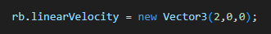

Test steps
- Call:
- Wait for two FixedUpdate cycles: yield return new WaitForFixedUpdate(); (twice).

Expected result
- rb.linearVelocity.magnitude < 1e-3f.
- robot.IsStopped == true;
- robot.IsEStopped == false.

Pass/Fail criteria
The test fails if the robot continues moving, or if the state flags do not reflect a normal stop.

TC-SIM-01: Simfeeder -> Mediator -> Robot, obstacle causes stop
Test ID: TC-SIM-01.
Class: SimFeeder_Integration_Tests.
Method: SimFeeder_To_Mediator_To_Robot_Stop.
Type: Play mode (integration).

Objective
Validate the end-to-end integration from simulated perception (SimFeeder) through the safety framework to the robot: when an obstacle is placed ahead of the robot, the robot should end up in a latched stopped state.

Preconditions / Setup
- GameObject(“robot”) with: Rigidbody(gravity disabled) and Robot component.
- A SimFeeder component attached to the same GameObject.
- An Obstacle is instantiated as a cube primitive:

Test steps
- Create the robot GameObject and attach Rigidbody, Robot and Simfeeder.
- Instantiate an obstacle three meters in front of the robot.
- Wait for two FixedUpdate cycles: yield return new WaitForFixedUpdate().

Expected result
- robot.IsStopped == true;
- rb.linearVelocity.magnitude < 1e-3f.

Pass/Fail criteria
If the robot is not stopped or still has non-negligible velocity, the integrated safety chain is not functioning correctly for this scenario.

Test execution summary
Test ID | Result (Pass/Fail) | Date run | Notes
TC-OBS-01 | Pass | 1-12-2025
TC-MED-01 | Pass | 1-12-2025
TC-MED-02 | Pass | 2-12-2025
TC-FP-01 | Pass | 2-12-2025
TC-RBT-01 | Pass | 3-12-2025
TC-SIM-01 | Pass | 3-12-2025

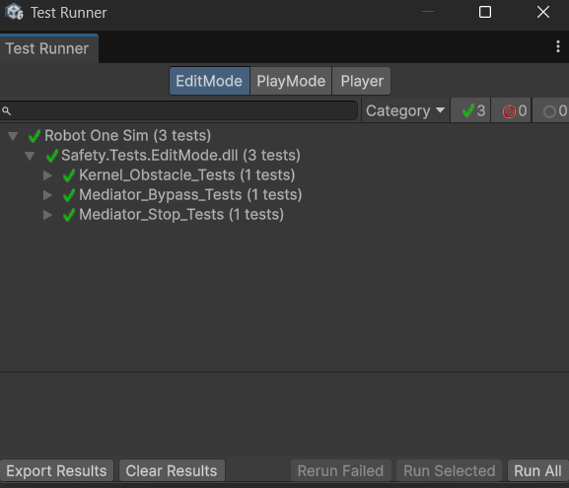
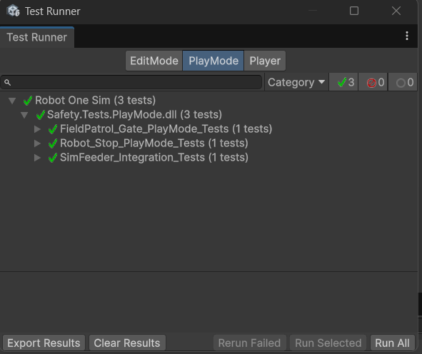

Conclusion and Recommendations
The current test demonstrated that:
- The SafetyKernel correctly issues a Stop decision when an obstacle is closer than the configured stop threshold.
- The Mediator:
  - Allows motion in a trivially safe snapshot and passes the command to the robot port.
  - Correctly applies a Stop decision from the safety kernel to the robot port including the appropriate reason.
- The Robot component responds correctly to a Stop command by stopping the rigidbody and updating its internal state flags.
- The FieldPatrol behaviour respects the robot’s stopped state and does not cause movement when the robot is stopped.
- The SimFeeder integration test confirms that, in a simple obstacle scenario, the whole chain from simulated sensing to actuation results in a latched Stop.

Recommended next steps:
Extend the tests with:
- Human detection / Speed & Separation Monitoring (SSM) scenarios.
- Geofence vialations and safe workspace enforcement.
- Communication loss / link-loss safety behaviour.

